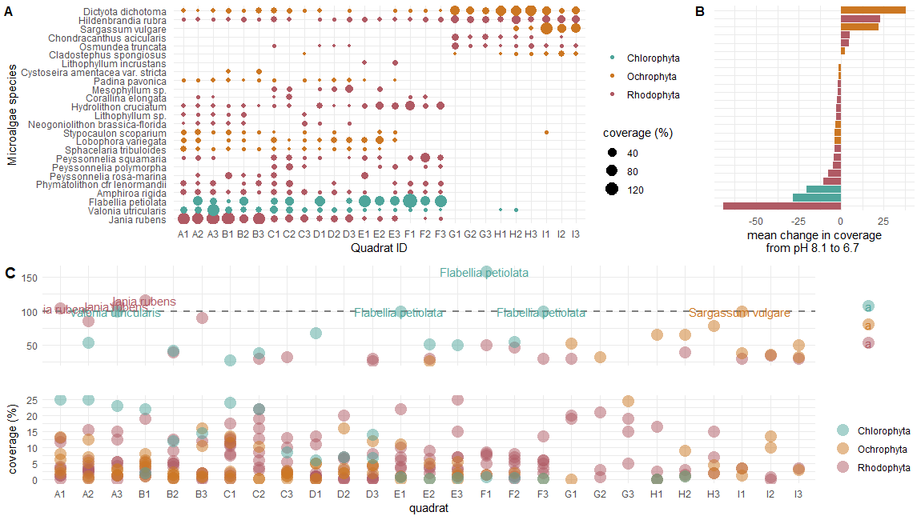

Fig 1. Microalgae species coverage amounts (%) from each sampled quadrat **(A)** demonstrate that several species of microalgae are absence from the most acidic environments (e.g. Jania rubens, Valonia utricularis, Flabellia petiolate) and new species arise (e.g. Dictyota dichotoma, Hildenbrandia rubra, Sargassum vulgare) **(B).** However, several of the values that correspond with the most significant changes in coverage are also greater than 100 **(C),** raising the question whether the values truly represent a percentage (as is indicated in the methods), suggesting there may have been an error when recording the data for a few species, or indicating that I (Beka) misunderstood the methods. (Beka looks forward to hearing thoughts from everyone else about this data!)

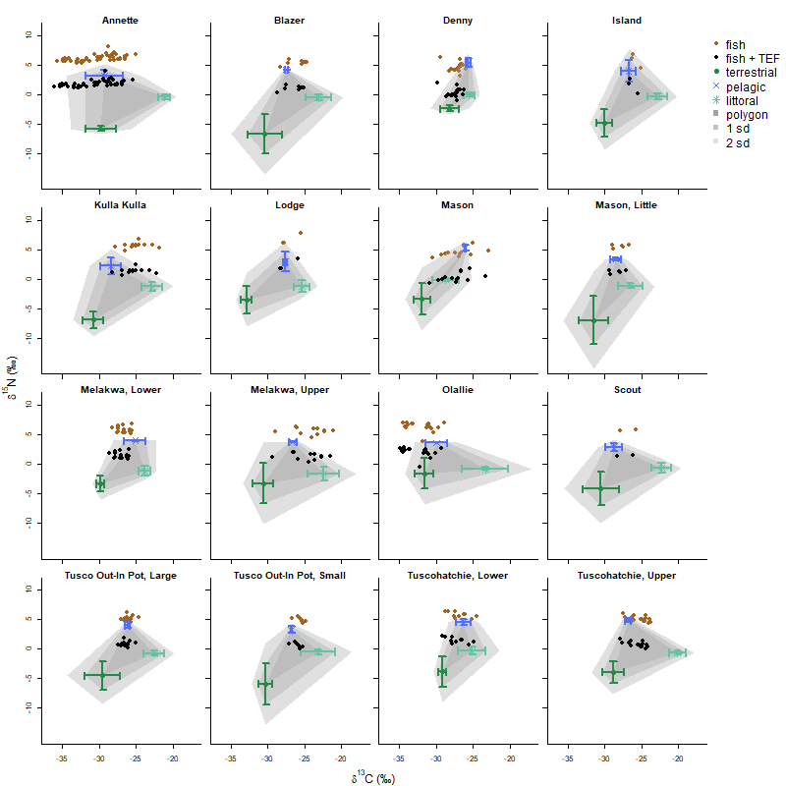

Fig 2. Data used in mixing models for each lake show the mean (± SD) of the carbon and nitrogen stable isotope ratios for terrestrial, pelagic, and littoral basal resources. The points show the stable isotope ratios of fish prior to (brown) and after (black) adjusting with trophic enrichment values from Bunn 2013.

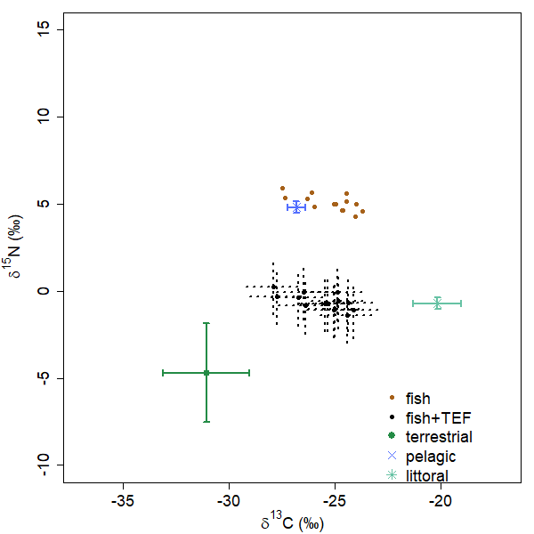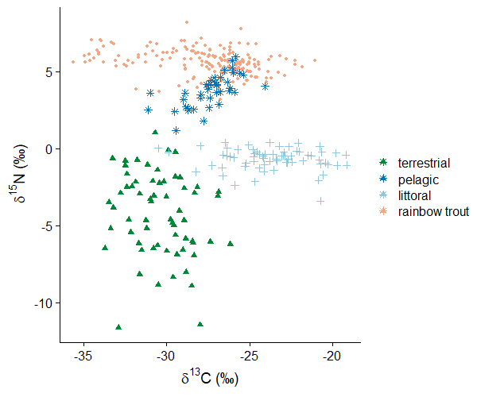

Fig 3. Base vs ggplot2 single isotope by plots.